Greetings from climate changer! Welcome to the project “Cut the loop”

We are the student who always work on research work some of our project get some national and international award one of our team get championship on 1ST International Conference on

Functional Textiles & Clothing, I I T,DELHI another team participating NASA Spaceapps challenge for 2 year and always selected on top50

Where everyone thinking about rigid and heavy electrical equipment ,we think about lightweight and flexible electrical equipment with simple design higher accuracy

**Problem**

In this session we are trying to solve the category ***Living In Our World*** sub category :**Warming Planet, Cool Ideas”** which demand the improvement of the Earth weather and/or ***eliminate processes*** that cause global warming. Your solution could be a technology, a movement, an idea

### [Living In Our World](https://2019.spaceappschallenge.org/challenges/living-our-world/)

[The Earth is composed of complicated systems – land, water, air, living things, and the planet itself. Understanding how these systems work together is important. Challenges in this category will ask you to craft solutions using NASA data – a story, a game, a video, any product of your design – that capture what it’s like to live on Earth.](https://2019.spaceappschallenge.org/challenges/living-our-world/)

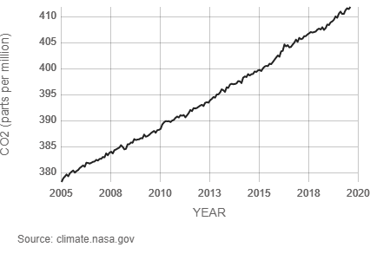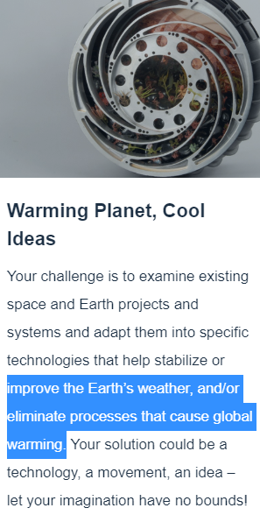

so why nasa interesting about global warming specially about co2 .Lets go and find from [NASA Climate Change](https://www.youtube.com/channel/UCP_hZt43bbGGf9ah6ATOvEg) department

(0:00 -1:00 minuit with voice)( <https://www.youtube.com/watch?v=f9F7yDjSdNA&feature=youtu.be>)

**Solution**

Humans have increased atmospheric CO2 concentration by more than a third since the Industrial Revolution began. This is the most important long-lived "forcing" of climate change[<https://climate.nasa.gov/causes/>]

A stronger greenhouse effect will warm the oceans and partially melt glaciers and other ice, increasing sea level. Ocean water also will expand if it warms, contributing further to sea level rise. [<https://climate.nasa.gov/causes/>]

So now as we know from NASA CO2 is one of the main reason for global warming so our project is to design a process that eliminate the burning of fuel that produce CO2

In our solution instead of burning gas(which produce CO2) to run the boiler to make electricity in many industry we will use solar energy to run the boiler

A blast of sun energy came to an parabolic mirror and then focused on a single point THAT GENERATE 550 DEGREE CELCIUS TEMPERATURE of a boiler which convert the water into stem by which we can make electricity from a generator by rotating its turbine

Initially this solution along can not fully replace the gas burning method But it can minimize the production of CO2 by producing maximum steam required by a industry , we must take this movement for commercializing our technological idea

As our project meet the main 3 criteria by having

1.an idea

2.a technology

3. a movement

And eliminate a process that casus global warming, so can confidently say that our project must achieve a award of galactic impact or Best Use of Hardware or Best use of Science.

From a rough calculation we can get

from a solar plant having 73 parabolic mirror (16 square meter ) we can get 3.5 ton stem per day that means 1277.5 ton stem per year. Without burning a single amount of gas

so by adopting this solution we can minimize a huge amount of Carbon di-oxide production

**Future plan**

In future

1. we will increase the efficiency of this product so that it can replace boiler
2. we will use it in other industry like food industry
3. we will use it as our heat reservoir
4. we will redesign it to use it in out household work

5 benefits

1. it will reduce global warming
2. in this era of global warming it can be easily commercialized
3. it is sustainable
4. from its by product we can get pure water
5. it is cost effective as no fuel is needed

thank you for being with us through out the presentation